Laboratory 1: Introduction to PSpice

Elizabeth Beisert

Eab150630

CE 3111.103

Jingchen Liang

**Objectives**

The objective of this lab is to familiarize the students with the PSpice software.

**Simulation results**

**Bias Point**

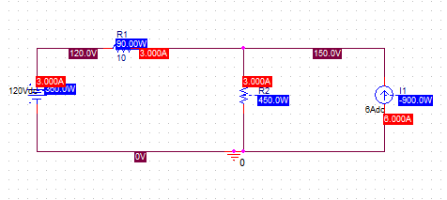

**DC Sweep**

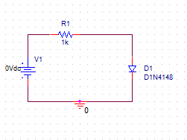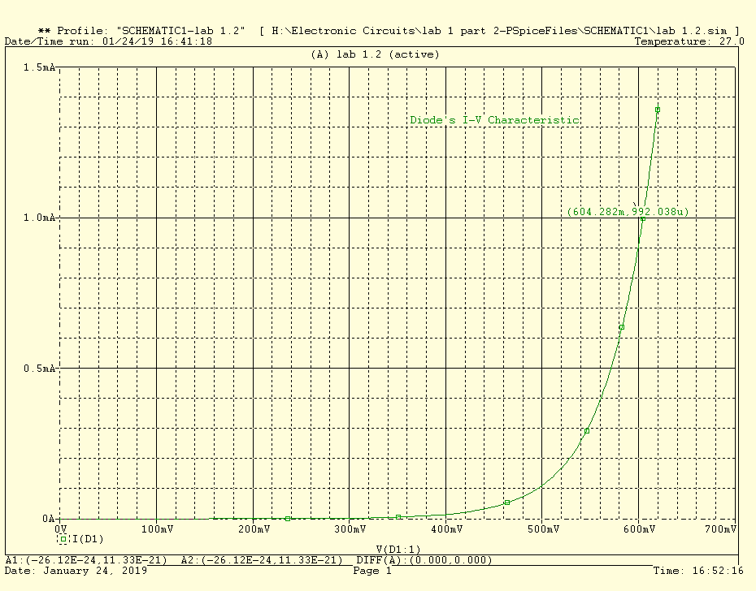

**AC Sweep**

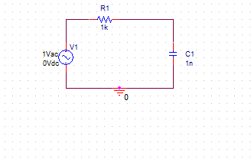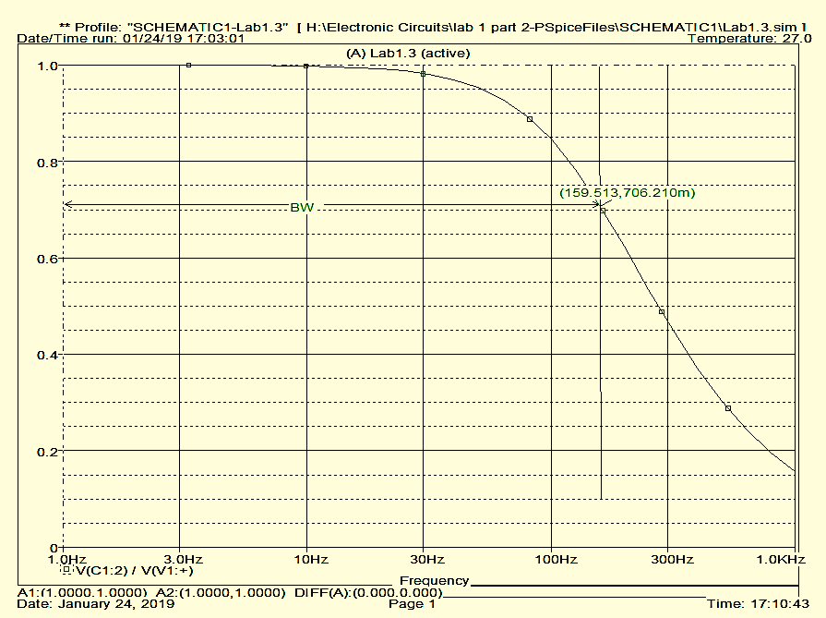

**Parametric Sweep**

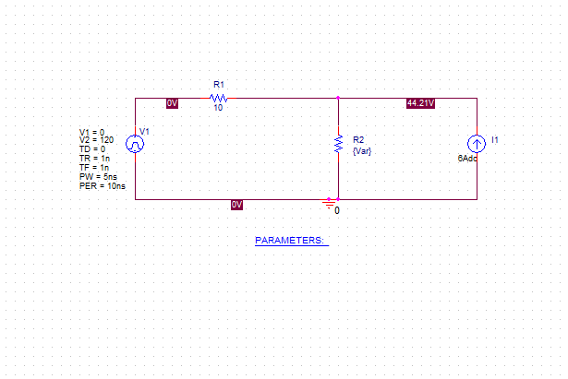

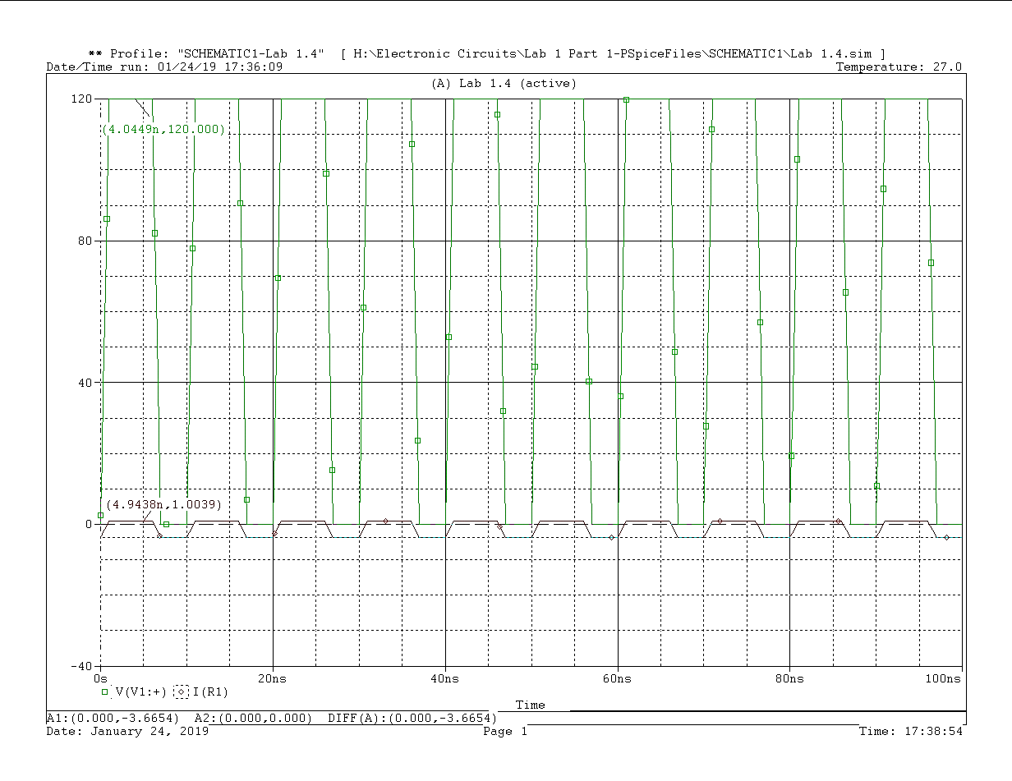

The voltage source is 120V from 0ns to 5ns, and 0V from 5ns to 10ns.

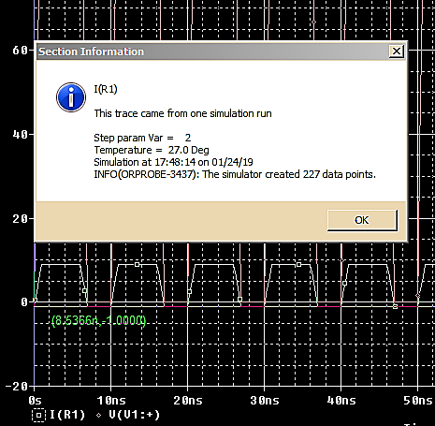

Marked Point (8.5366n, 1.0000)

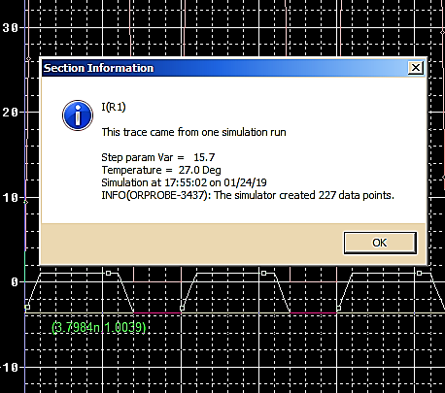

Marked Point (1.7984n, 1.0039)

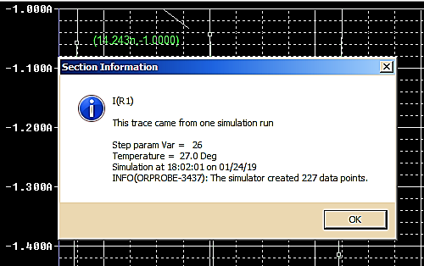

Marked Point (14.243n, -1.0000)

**Analysis Questions**

What value of R2 creates a 1A current in R1 when V1 = 0V?

If 1A is going through R1, 5A must be going through R2, and they will both be in parallel.

$$1A × 10Ω = 5A × R2$$

$$10V = 5A ×R2$$

$$R2=\frac{10V}{5A}=2Ω$$

What value of R2 creates a 1A current in R1 when V1 = 120V?

Current through R1 to right Current through R1 to left

$120+1A×10V= 5A×R2$ $120-1A×10V= 7A×R2$

$130V=5A×R2$ $110V=7A×R2$

$R2=\frac{130V}{5A}=26Ω$ $R2=\frac{110V}{7A}=15.714Ω$

**Thought Questions**

1. What does the I-V characteristic plotted by the DC Sweep illustrate about diodes?

Under DC conditions, the current grows exponentially with respect to the voltage across it.

1. What is the significance of the 3-dB point you found with the AC Sweep?

The 3dB point is the point at which the signal has half of the max power.

1. If the current direction in R1 is reversed for the Parametric Sweep, will your solution be affected? If yes, give your reason and reevaluate the circuit to illustrate the difference. If not, explain why not. In either case, provide calculations or a graphical solution as proof.

For the 120V case, it has already been calculated in both directions in the Analysis Questions. If the current is reversed at 0V, then yes, the solution would be affected because it would not exist. Calculations on the next page.

$$6A= -1A+7A$$

$$-1A×10Ω=7A×R2$$

$$-10V=7A×R2$$

$$R2=\frac{-10V}{7A}=Does Not Exist Because Resistance Can Only Be Positive$$

**Conclusion**

The student has learned the basics of PSpice as shown in the lab. The simulations were congruent with the calculated values.